MSDS 6372: Project 1

Submitted by:

Senthil Kumar

Simerpreet Reddy

Taifur Chowdhury

Date: 10/4/2020

**1 - Introduction**: In this document report, we present the different models created to predict Life Expectancy of a country’s population based on different variables ranging from immunization factors, mortality factors, economic factors, social factors and other health related factors. We also dive deep into some variables which strongly influence Life Expectancy of a country’s population.

**2 - Data Description:** The data set we have captures 22 columns for 193 countries from year 2000-2015 over 2938 rows. The data set has 20 predicting variables. Some of the variables that we will be talking about throughout our analysis are listed below:

Life expectancy – Life Expectancy in age.

Status- Developed or Developing status of a country.

percentage expenditure- Expenditure on health as a percentage of Gross Domestic Product per capita (%).

Total expenditure- General government expenditure on health as a percentage of total government expenditure (%)

GDP- Gross Domestic Product per capita (in USD)

Population- Population of the country

Income composition of resources: Human Development Index in terms of income composition of resources (index ranging from 0-1)

Schooling- Number of years of Schooling (years).

Adult Mortality - Adult Mortality Rates of both sexes (probability of dying between 15 and 60 years per 1000 population)

Alcohol- Alcohol, recorded per capita (15+) consumption (in liters of pure alcohol).

Immunizations- Data around Polio, Measles, Hepatitis B and Diphtheria.

HIV/AIDS- Deaths per 1 000 live births HIV/AIDS (0-4 years).

thinness 1-19/ 5-9 years - Prevalence of thinness among children and adolescents for Age 10 to 19 (%) and 5-9 years as well.

BMI: Average Body Mass Index of entire population

infant deaths: Number of Infant Deaths per 1000 population

under-five deaths: Number of under-five deaths per 1000 population

**3 - Exploratory Data Analysis:**

**3.1** - Analyzing the categorical variables: Status and Country

We have data for 193 countries, out of which 161 are categorized (column Status) as ‘developing’ and 32 are categorized as ‘developed’. Looking at Life Expectancy variation by ‘Status’, we see that there is a clear distinction between the Life expectancy of country’s population by its ‘Status’.

**Figure 1**

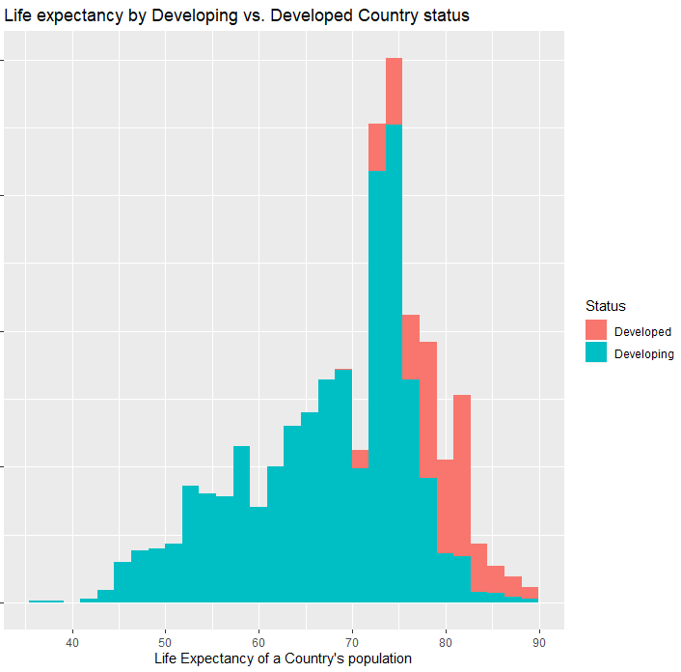

Country is just the country’s name, so we will not be analyzing this column any further.

**3.2 - Correlation:** To study the relationships among different variables, we created scatterplots, please refer to pages 11-13 for scatter plots showing the correlation among all the variables.

Following variables have a significant correlation with Life Expectancy: Schooling(0.7276), Income_composition_of_resources(0.7211) , Adult Mortality (-0.7025), HIV_AIDS( -0.5922), BMI(0.5420), thinness_1_19_years(-0.4578), thinness_5_9_years(-0.4575) ), GDP(0.4413), percentage_expenditure(0.4096), Alcohol (0.4027), Diphtheria(0.3413 ) and Polio(0.3273).

There are also multiple variables that highly correlated to each other:

Variables that are highly correlated to each other: infant_deaths and under_five_deaths at 0.9969; GDP and percentage_expenditure at 0.9593; thinness_5_9_years and thinness_1_19_years at 0.9279; Schooling and Income composition of resources at 0.7847.

Please refer to page 14 for correlation matrix of all the variables.

**3.3 - Missing Data:** Out of 2938 rows, we see that there are 10 rows missing Life Expectancy. There are several other variables that are missing values over multiple rows, we will handle the missing values for necessary variables as we build the models. We also notice that there are several variables that have value ‘0’ for them. This does not look right, but we will be leaving those values as is for now.

**3.4 - Outliers**: We notice a few countries where the Life expectancy values is either too high or low. For ex. obs. 1128 Haiti (2010) .

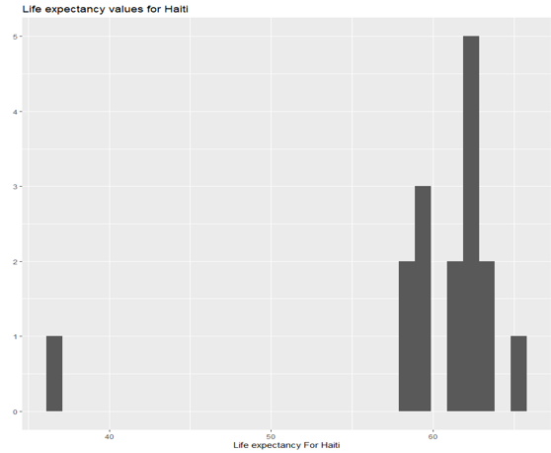

1. **- Objective 1**: Build and compare data models to predict life expectancy of a country’s population.

**4.1** - Simple and highly interpretable model:

**Model** **1**: Building model 1 using variables with correlation to Life Expectancy. Running GLM, variable Alcohol proves to be statistically insignificant. Thus, it was removed from the model.

Life_Expectancy = $β0$ + $β1Adult_Mortality$ + $β2HIV_AIDS$ + $β3BMI$ + $β4thinness_1_19_years$ + $β5GDP$ + $β6Diphtheria$ + $β7Polio$ + $β8Schooling$

**Model 2**: Model 1 is a simple and highly interpretable model but looking at the residual plots (please refer to page 22), it can be improved by adding log transforms to Life expectancy, GDP and HIV_AIDS. After adding log transforms, BMI became statistically insignificant, so it was removed from the model. Please refer to page 25 for Model 2 residual plots.

Log_Life_Expectancy = $β0$ + $β1Adult_Mortality$ + $β2log_HIV_AIDS$ + $β3thinness_1_19_years$ + $β4log_GDP$ + + $β5Diphtheria$ + $β6Polio$ + $β7Schooling$

Comparing the PRESS Statistic (CV) and R-sq for both the models.

|  |  |  |  |
| --- | --- | --- | --- |
| **Model** | **PRESS STATISTC (CV)** | **R-sq** | **Adj R-sq** |
| Model 1 | 41012.174 | 0.8218 | 0.8212 |
| Model 2 | 8.48 | 0.8454 | 0.8449 |

Fitting model 2: As Model 2 has significantly lower PRESS Statistic, Model 2 is considered better.

Mean(Log_Life_Expectancy|=

3.972903921-0.000230961*Adult_Mortality -0.041370168log_HIV_AIDS - 0.002062371* thinness_1_19_years **+** 0.007546849*log_GDP **+** 0.000397376*Diphtheria **+** 0.000213914*Polio **+** 0.012198913*Schooling

* 1. - **Interpretation**: According to Model 2, Life_Expectancy of a country’s population is related to the following variables in below described ways:

Though, it is not practical, but if all the factors considered on this model are 0, Life Expectancy of a country’s population will e3.972903921 = 53.13.

Adult_Mortality: Keeping all other factors constant, it is estimated that, a one unit increase in Adult_Mortality is associated with a ( $e^{-0.000230961}$ = 0.999769066) 0.023% decrease in median Life_Expectancy. 95% confidence interval for this decrease is between ( $e^{-0.000206568}$ = 0.999793) 0.021% and ( $e^{-0.000255354}$ = 0.999744679) 0.026%.

HIV_AIDS: Keeping all other factors constant, it is estimated that, a doubling of HIV_AIDS is associated with a $(2^{- 0.041370168}$ =0.959473898) 4.053% decrease in median Life_Expectancy. 95% confidence interval for this decrease is between ( $2^{-0.039309427}$ = 0.961453) 3.855% and ( $2^{-0.04343098}$ = 0.957498707) 4.25%.

thinness_1_19_years: Keeping all other factors constant, it is estimated that, a one unit increase in thinness_1_19_years is associated with a ( $e^{-0.002062371}$ = 0.997939754) 0.206% decrease in median Life_Expectancy. 95% confidence interval for this decrease is between ( $e^{-0.001466004}$ = 0.99853507) 0.146% and ( $e^{-0.002658737}$ = 0.997344794) 0.266%.

GDP: Keeping all other factors constant, it is estimated that, keeping all other factors constant, a doubling of GDP is associated with a $(2^{0.007546849}$ =1.007575398) 0.758% increase in median Life_Expectancy. 95% confidence interval for this decrease is between ( $2^{0.0059571}$ = 1.005974879) 0.597% and ( $2^{0.009136598}$ = 1.009178464) 0.918%.

Diphtheria: Keeping all other factors constant, it is estimated that, Keeping all other factors constant, a one unit increase in Diphtheria is associated with a ( $e^{0.000397376}$ = 1.000397455) 0.04 % increase in median Life_Expectancy. 95% confidence interval for this decrease is between ( $e^{0.000258171}$ = 1.000258204) 0.026% and ( $e^{0.000536581}$ = 1.000536725) 0.054%.

Polio: Keeping all other factors constant, it is estimated that, Keeping all other factors constant, a one unit increase in Polio is associated with a ( $e^{0.012198913}$ = 1.000213937) 0.021 % increase in median Life_Expectancy. 95% confidence interval for this decrease is between ( $e^{0.000074262}$ = 1.000074265) 0.007% and ( $e^{0.000353565}$ = 1.000353628) 0.035%.

Schooling: Keeping all other factors constant, it is estimated that, Keeping all other factors constant, a one unit increase in Schooling is associated with a ( $e^{0.012198913}$ = 1.012273623) 1.227 % increase in median Life_Expectancy. 95% confidence interval for this decrease is between ( $e^{0.011117162}$ = 1.011179187) 1.18% and ( $e^{0.013280664}$ = 1.013369244) 1.337%.

* 1. - **Complex model (Model3)**: After running feature selection techniques and adding interaction with the variable ‘Status’, below is the model that we have created:

Log_Life_Expectancy(for Countries with Status=’Developing’) = $β0$ + $β1log⁡_HIV_AIDS+ β2Schooling$ + $β3Adult_Mortality$ + $β4Income_composition_of_resources$ + $β5log_percentage_expenditure$ + $β6Diphtheria$

Log_Life_Expectancy(for Countries with Status=’Developed’) = $β0$ + $β1log⁡_HIV_AIDS+ β2Schooling$ + $β3Adult_Mortality$ + $β4Income_composition_of_resources$ + $β5log_percentage_expenditure$ + $β6Diphtheria$ + $β7Income_compos*Status Developed$

**Comparing models**

Comparing the PRESS Statistic (CV) and R-sq for all the different models.

|  |  |  |  |
| --- | --- | --- | --- |
| **Model** | **PRESS STATISTC (CV)** | **R-sq** | **Adj R-sq** |
| Model 1 | 41012.174 | 0.8218 | 0.8212 |
| Model 2 | 8.48 | 0.8454 | 0.8449 |
| Model 3 (with interaction) | 7.78 | 0.8502 | 0.8497 |

Model 3 is the preferred model for the following reasons:

1. From Figure 1, we can see that the ‘Status’ of a country strongly affects the Life expectancy of its population. Model 3 takes this into account.
2. Model 3 has better CV statistics, R-sq and Adjust R-sq.
3. Model 3 has fewer variables with log transforms, so it is easier to interpret.

**Fitting model 3:**

Mean(Log_Life_Expectancy{for Countries with Status=’Developing’}) = 3.972351146 $-0.041640209*log_HIV_AIDS*+ 0.008289124*Schooling$-0.000211583 $*Adult_Mortality$ + 0.104705191 $*Income_composition_of_resources$ + $0.006853873*log_percentage_expenditure$ + $0.000473442*Diphtheria$

Mean(Log_Life_Expectancy{for Countries with Status=’Developed’}) = 3.972351146 $-0.041640209*log_HIV_AIDS-+ 0.008289124*Schooling$ + $-0.000211583*Adult_Mortality$ + 0.104705191 $*Income_composition_of_resources$ + $0.006853873*log_percentage_expenditure$ + $0.000473442*Diphtheria$ + $0.009912599*Income_compos*Status Developed$

**Outliers:**

* Outlier Analysis using all the variables in Model3: We see obs. 1128 (Haiti-2010) has a very high cook’s D. Please see refer to Page 33 – Cook’s D : Graph 1
* Running model3 after removing obs. 1128 did not impact the model. So we can keep obs. 1128 in the data set. Please refer to Page 33 – Cook’s D Graph 2.

**5 - Objective 2:**

For our nonparametric regression, we have chosen regression tree method to build our model using life expectancy as the response variable. Below were the findings from the model:

1. We notice that HIV/AIDS, Income composition of resources, adult mortality, and BMI are the variables that regression tree method used to build the model.
2. Model had a Residual mean deviance which is the sum of square error of 12.96.
3. These variables are also important compared to the rest of the variables in terms of calculating predictive life expectancy values. (Please refer to Page 31 – Regression analysis chart)

Cross-validation:

In our cross-validation plot (page 32), we can notice that there is not much of a deviation between our predicted life expectancy values and test data set’s life expectancy values. The plot also indicates that our prediction data for age range of 60-80 is very close to the actual data. The error variance of 55-75 age group is less compare to age groups of 55 or less and age groups of 80 or more. The mean squared error for this regression is 2.12

**6- Conclusion:**

By comparing model 3 to regression tree model, we can conclude that model 3 is the better model since it has a lower ASE score of 0.00333 (compared to 2.12 from regression tree). We notice that HIV/AID, Income composition of resources, and adult mortality are important explanatory variables which significantly predict life expectancy for both the models. But Model 3 utilizes other important variables as well, such as Status, GDP, Schooling, Diptheria immunization and more. Life expectancy of a country’s population depends on numerous factors such as Immunization, mortality factors, and socioeconomic factors, and Model 3 considers all these in some ways. It has the lowest ASE as well. Thus, we believe Model 3 is a better model among all these.

**7 – If we had more time, we could have focused more on the following:**

1. **Data Cleanse** –
   1. - We used SAS for objective 1 where SAS automatically handled(skipped) null/problematic records. If we had more time, we could have replaced missing values by more appropriate values and could have used the complete data set. Most of the time SAS skipped around 600 problematic rows. Thus, considering around 80% of the total data for modelling. Cleanse might have helped us consider more data.
   2. - For objective 2, we used R, so we had to explicitly handle missing values, we replaced the missing values by mean values for the important variables. As mean is not always the best solution, we could have spent some more time finding more appropriate replacement for the missing values.
2. Analyze other non-parametric models: For objective 2, we researched the following techniques: KNN, regression tree, Spline. We got stuck at predicting continuous variables using KNN, if we had more time we could have made that work. We could also use a better understanding on regression trees.

**Appendix:**

LED <-read.csv(file.choose())

Reading the structure of the data

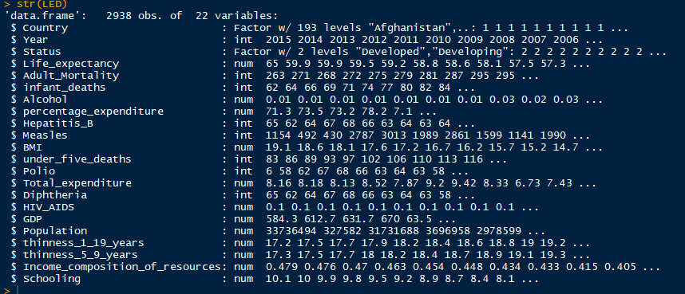

Reading the summary of the data

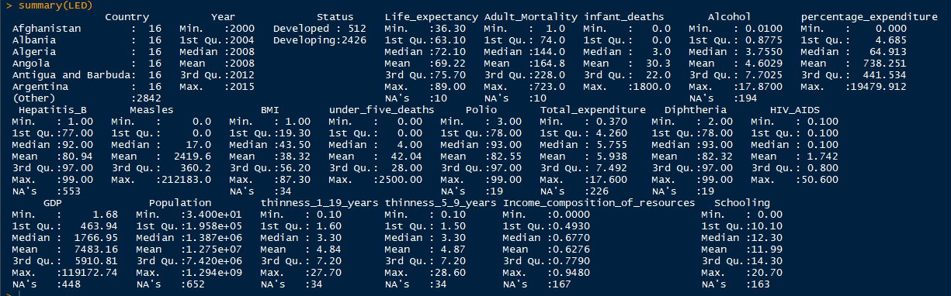

Some similar analysis in SAS

**proc** **means** data=LED n mean max min range std;

output out=meansout mean=mean std=std;

title 'Summary of LifeExpectancyData';

**run**;

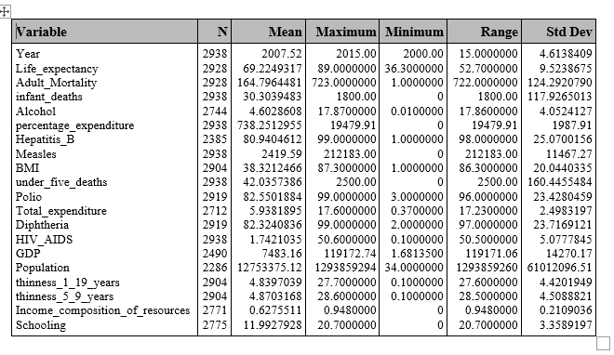

#Missing data

LED %>% filter(is.na(Life_expectancy))

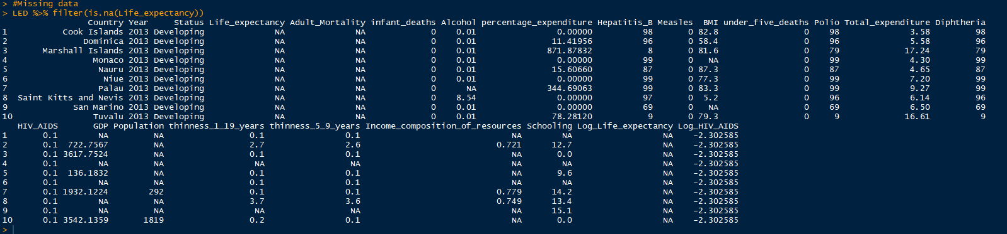





Scatter Plots:

plot(LED[,c(4,5,6,7,8,9,10,11)])

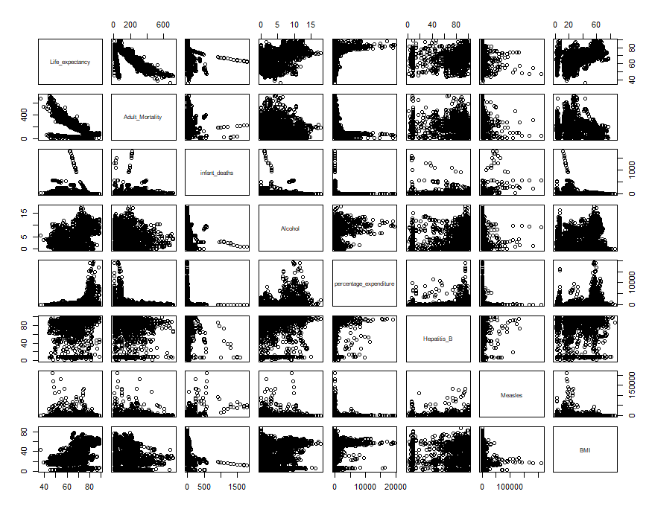

plot(LED[,c(4,12,13,14,15,16,17,18)])

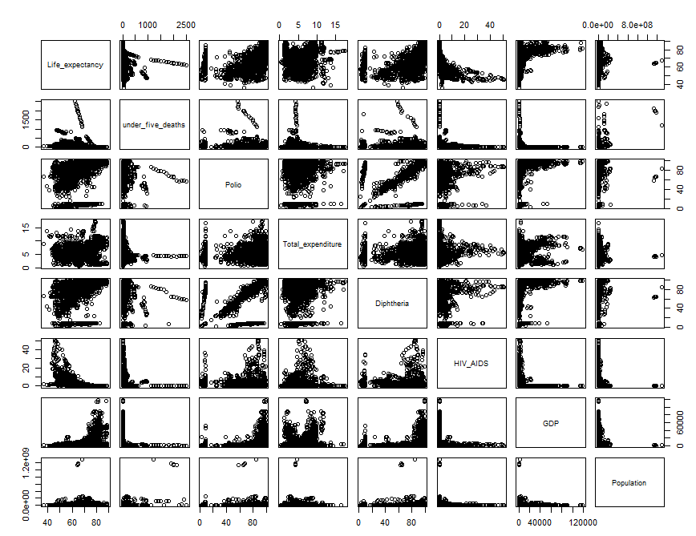

plot(LED[,c(4,19,20,21,22)])

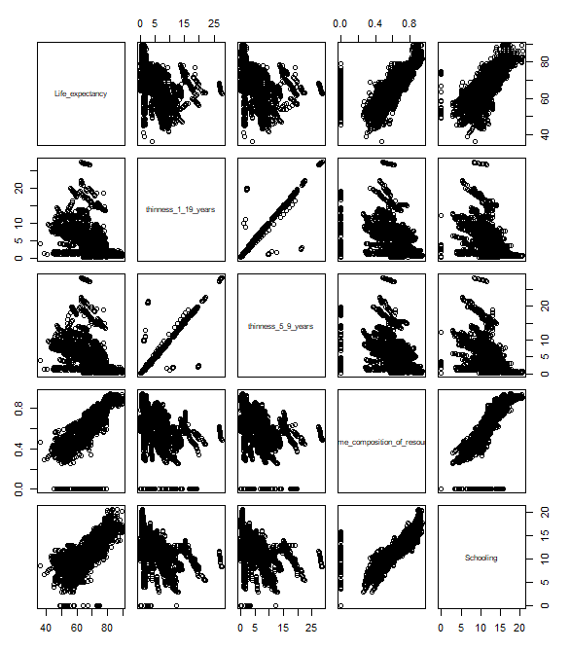

**Correlation:**

**proc** **reg** data=LED corr plots(label) = (rstudentleverage cooksd);

model Life_expectancy= Year Adult_Mortality infant_deaths Alcohol percentage_expenditure Hepatitis_B Measles BMI under_five_deaths Polio Total_expenditure Diphtheria HIV_AIDS GDP Population thinness_1_19_years thinness_5_9_years Income_composition_of_resources Schooling / VIF;

**run**; **quit**;

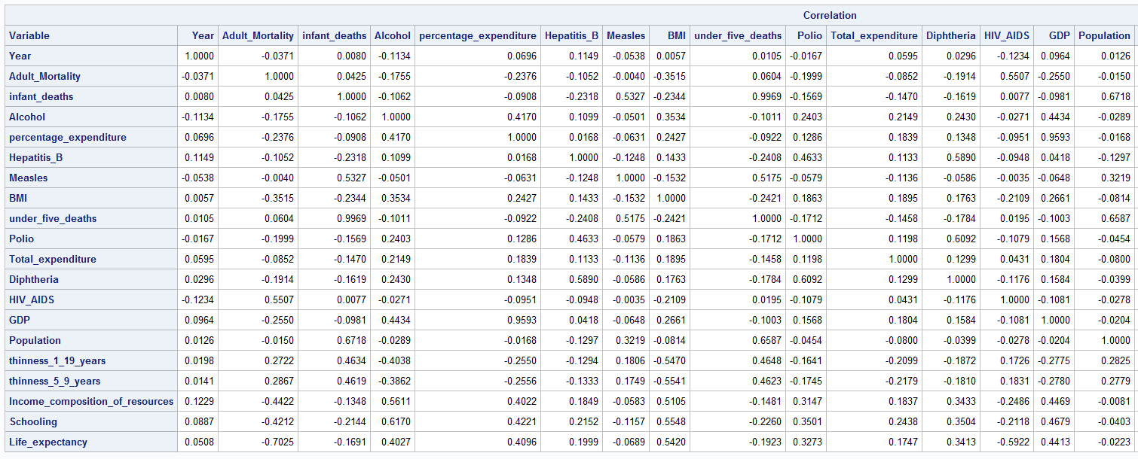

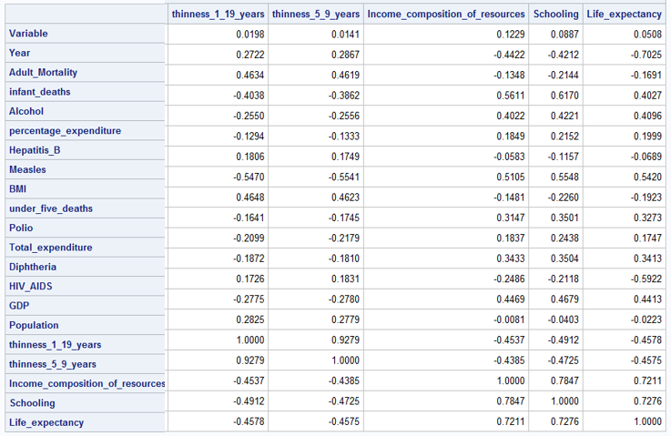

Outliers:

#Missing data

LED_Haiti <-LED %>% filter((Country == 'Haiti'))

ggplot(LED_Haiti) + geom_histogram(mapping = aes(x= Life_expectancy, fill = Year)) +

ggtitle("Life expectancy values for Haiti") + ylab("") +xlab("Life expectancy For Haiti")

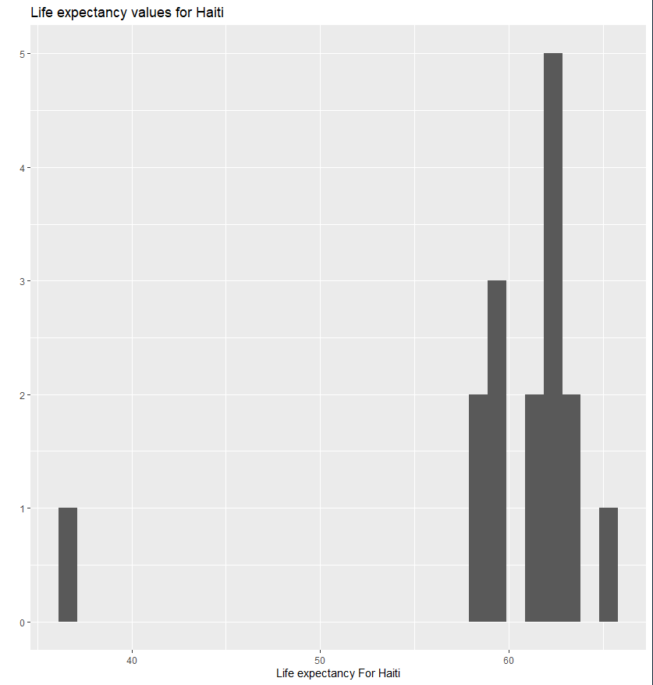

Models:

**proc** **reg** data=LED corr plots(label) = (rstudentleverage cooksd);

model Life_expectancy= Year Adult_Mortality infant_deaths Alcohol percentage_expenditure Hepatitis_B Measles BMI under_five_deaths Polio Total_expenditure Diphtheria HIV_AIDS GDP Population thinness_1_19_years thinness_5_9_years Income_composition_of_resources Schooling / VIF;

**run**; **quit**;

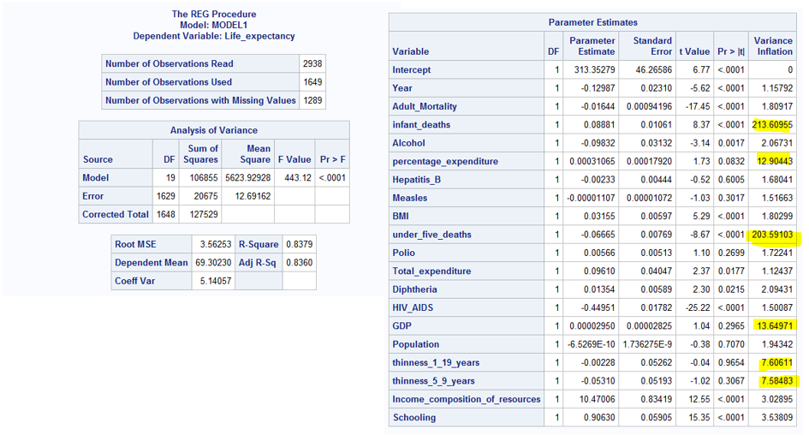

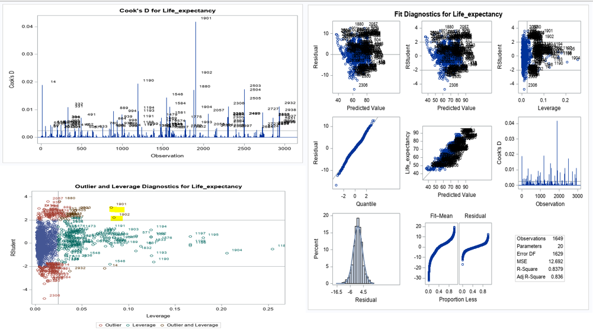

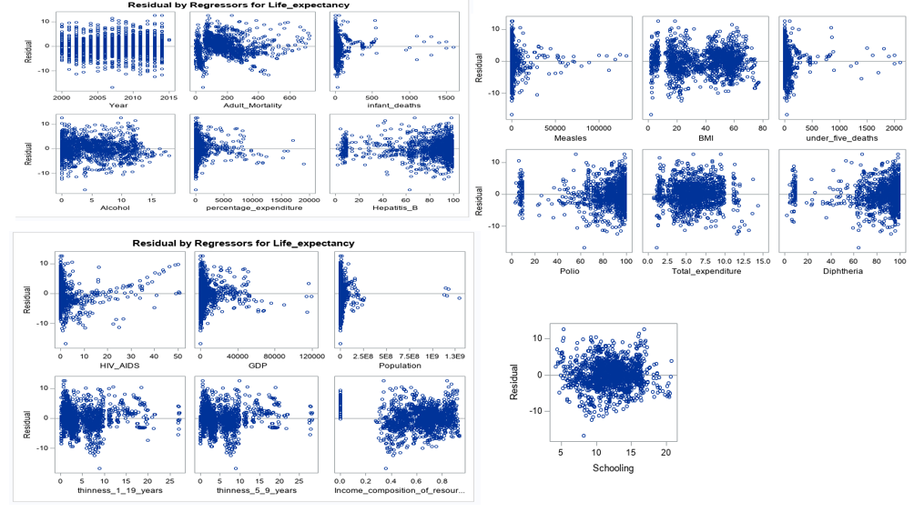

*Important observations;

*1) infant_deaths and under_five_deaths are highly correlated at 0.9969. Take infant_deaths out;

*2) GDP and percentage_expenditure are highly correlated at 0.9593. Take GDP out ;

*3) thinness_5_9_years and thinness_1_19_years 0.9279. Take thinness_5_9_years out;

*4) What do we do about under_five_deaths and Diphtheria? From VIFs, it looks like there's a correlation among these, but looking at the correlation factors above, we see it is -0.1784. So, we can keep them both in the model;

* Take infant_deaths,percentage_expenditure and GDP out and check VIFs;

**proc** **reg** data=LED corr plots(label) = (rstudentleverage cooksd);

model Life_expectancy= Year Adult_Mortality Alcohol percentage_expenditure Hepatitis_B Measles BMI under_five_deaths Polio Total_expenditure Diphtheria HIV_AIDS Population thinness_1_19_years Income_composition_of_resources Schooling / VIF;

**run**; **quit**;

* Looking at the residual plots, it feels necessary to do some transformations.;

**data** LED;

SET LED;

log_Life_expectancy = log(Life_expectancy);

log_percentage_expenditure = log(percentage_expenditure);

log_Adult_Mortality = log(Adult_Mortality);

log_Hepatitis_B = log(Hepatitis_B);

log_Measles = log(Measles);

log_BMI = log(BMI);

log_under_five_deaths = log(under_five_deaths);

log_Polio = log(Polio);

log_Total_expenditure = log(Total_expenditure);

log_Diphtheria = log(Diphtheria);

log_HIV_AIDS = log(HIV_AIDS);

log_Population = log(Population);

log_GDP = log(GDP);

**run**;

**proc** **reg** data=LED corr plots(label) = (rstudentleverage cooksd);

model log_Life_expectancy= Year Adult_Mortality Alcohol log_percentage_expenditure log_GDP Hepatitis_B log_Measles BMI log_under_five_deaths Polio Total_expenditure Diphtheria log_HIV_AIDS log_Population thinness_1_19_years Income_composition_of_resources Schooling / VIF;

**run**; **quit**;

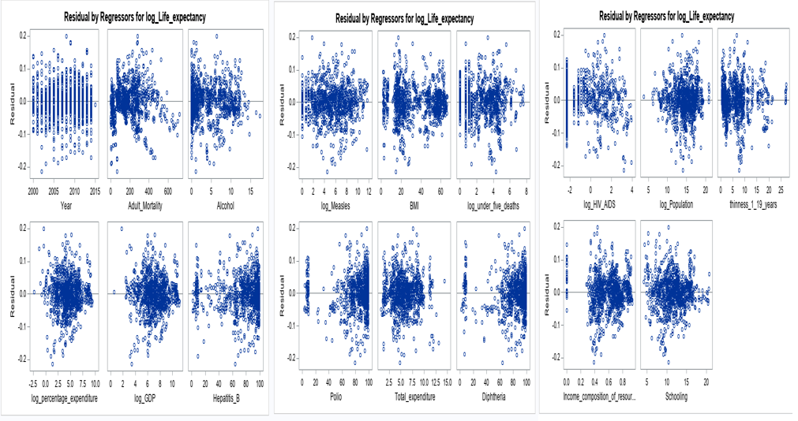

Model 1: Using variables with high correlation to Life_Expectancy

**PROC** **GLM** DATA= LED plots = all;

title "Model 1 WITH VARIABLES with correlation to Life_Expectancy ";

class Status;

model Life_expectancy = Adult_Mortality HIV_AIDS BMI thinness_1_19_years GDP Alcohol Diphtheria Polio Schooling / solution ;

output out = Customsel ;

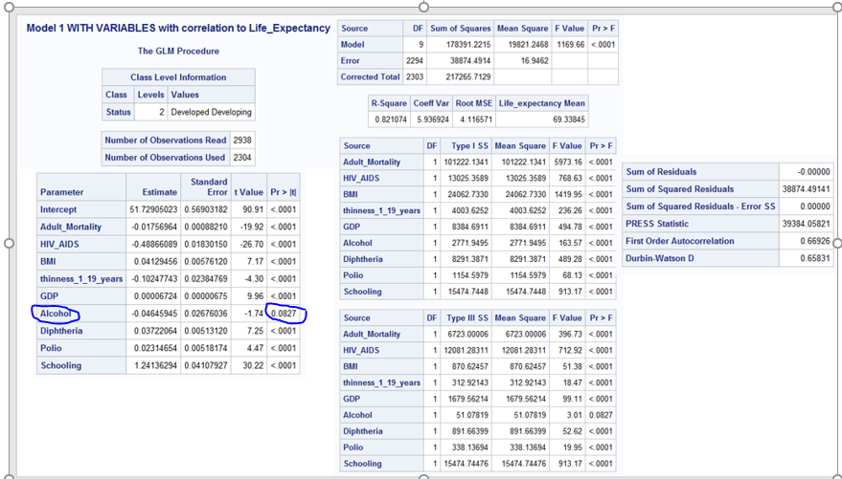

Variable Alcohol being statistically insignificant, removing it from the model.

**Revised Model1**

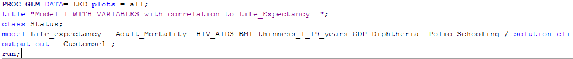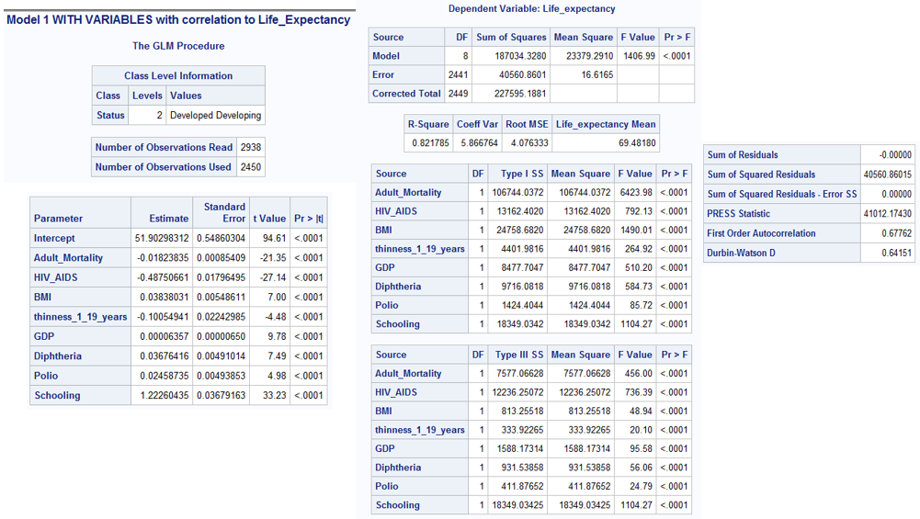

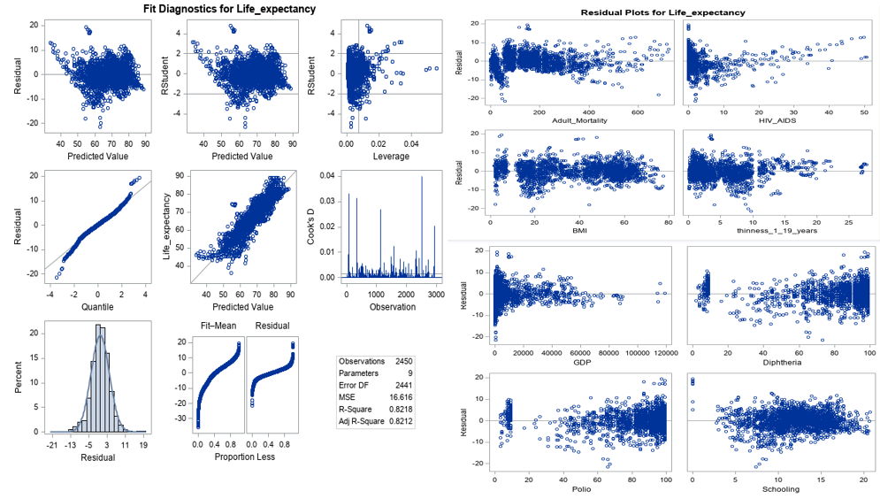

**Model2**: After taking log on Life_Expectancy, HIV_AIDS and GDP.



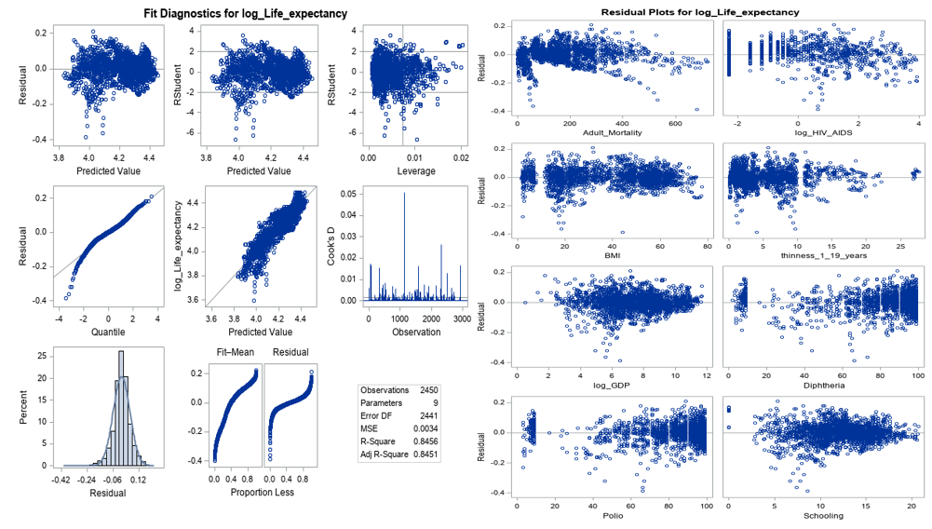

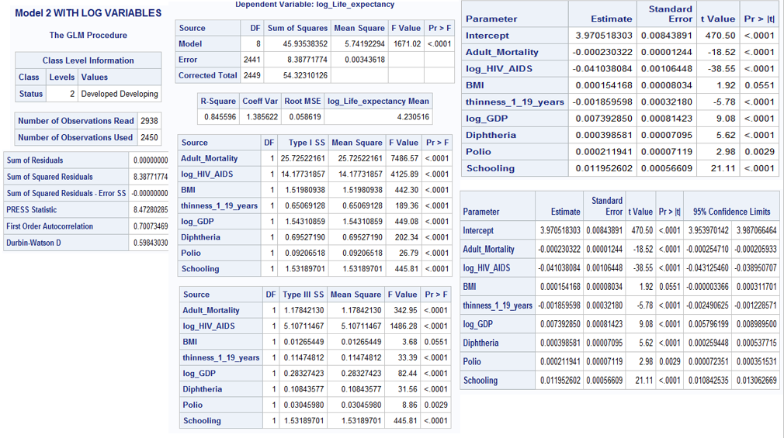

**Revised Model 2:** After taking log transform, BMI becomes statistically insignificant. Revising the model to remove BMI as a model parameter.



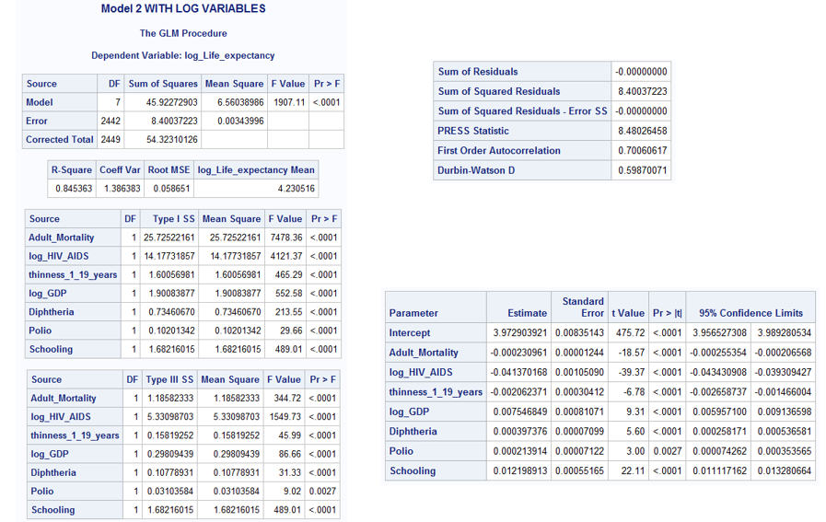

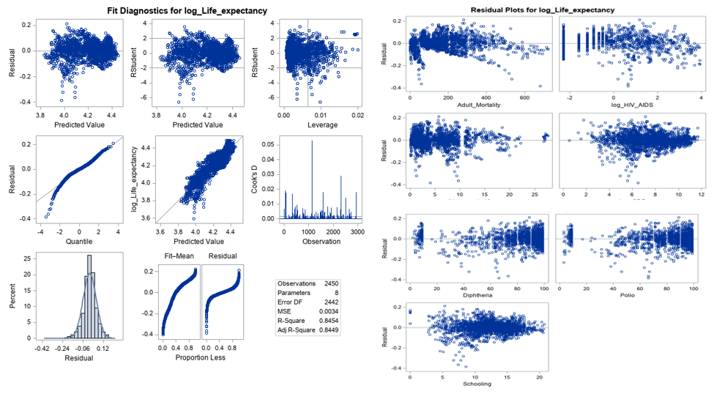

**Finding a complex model: Run models using different feature selection techniques (primarily CV)**

* Model assesment using ASE;

*Run different models using partition fraction(test = .7) and ASEPlots ;

**PROC** **GLMSELECT** DATA= LED plots(stepaxis = number) = (criterionpanel ASEPlot) seed = **1**;

title "**Forward** selection using CV Press as stop criteria with ASE";

partition fraction(test = **.5**);

class Status;

model log_Life_expectancy= Year Adult_Mortality Alcohol log_percentage_expenditure Hepatitis_B log_Measles BMI log_under_five_deaths Polio Total_expenditure Diphtheria log_HIV_AIDS log_Population thinness_1_19_years Income_composition_of_resources Schooling / selection = Forward(stop=CV);

output out = Forwardsel ;

**run**;

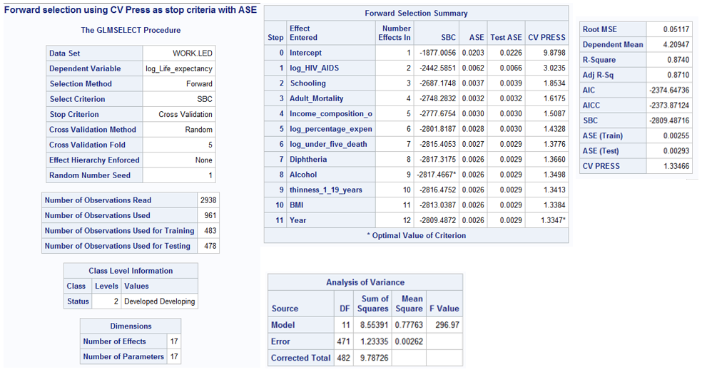

**PROC** **GLMSELECT** DATA= LED plots(stepaxis = number) = (criterionpanel ASEPlot) seed = **1**;

title "**Backward** selection using CV Press as stop criteria with ASE";

partition fraction(test = **.5**);

class Status;

model log_Life_expectancy= Year Adult_Mortality Alcohol log_percentage_expenditure Hepatitis_B log_Measles BMI log_under_five_deaths Polio Total_expenditure Diphtheria log_HIV_AIDS log_Population thinness_1_19_years Income_composition_of_resources Schooling / selection = backward(stop=CV);

output out = Backwardsel ;

**run**;

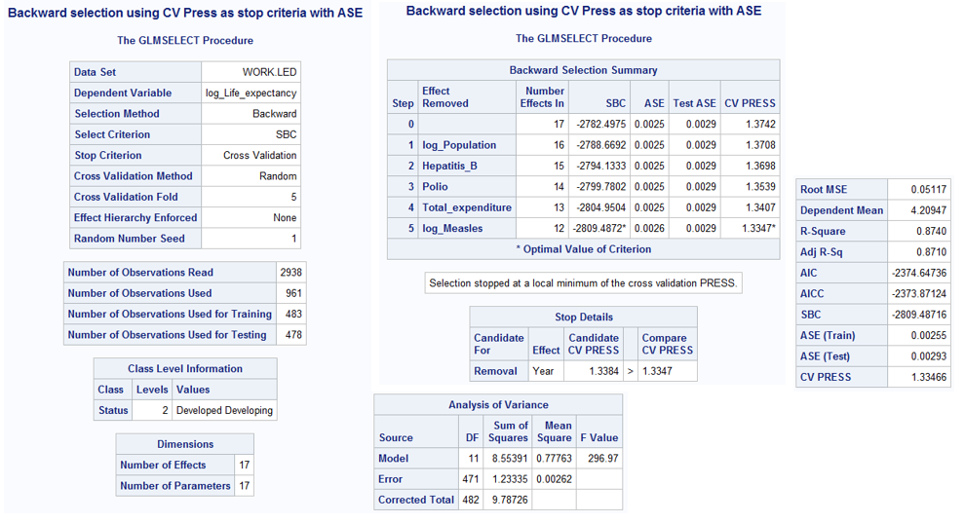

**PROC** **GLMSELECT** DATA= LED plots(stepaxis = number) = (criterionpanel ASEPlot) seed = **1**;

title "**Stepwise** selection using CV Press as stop criteria with ASE";

partition fraction(test = **.5**);

class Status;

model log_Life_expectancy= Year Adult_Mortality Alcohol log_percentage_expenditure Hepatitis_B log_Measles BMI log_under_five_deaths Polio Total_expenditure Diphtheria log_HIV_AIDS log_Population thinness_1_19_years Income_composition_of_resources Schooling / selection = Stepwise(stop=CV);

output out = Stepwisesel ;

**run**;

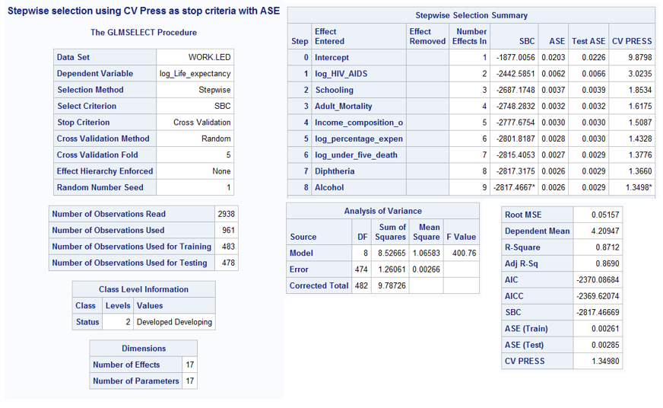

**PROC** **GLMSELECT** DATA= LED plots(stepaxis = number) = (criterionpanel ASEPlot) seed = **1**;

title "**LASSO** selection using CV Press as stop criteria with ASE";

partition fraction(test = **.5**);

class Status;

model log_Life_expectancy= Year Adult_Mortality Alcohol log_percentage_expenditure Hepatitis_B log_Measles BMI log_under_five_deaths Polio Total_expenditure Diphtheria log_HIV_AIDS log_Population thinness_1_19_years Income_composition_of_resources Schooling / selection = lasso( choose = cv) CVDETAILS;

output out = LASSOsel ;

**run**;

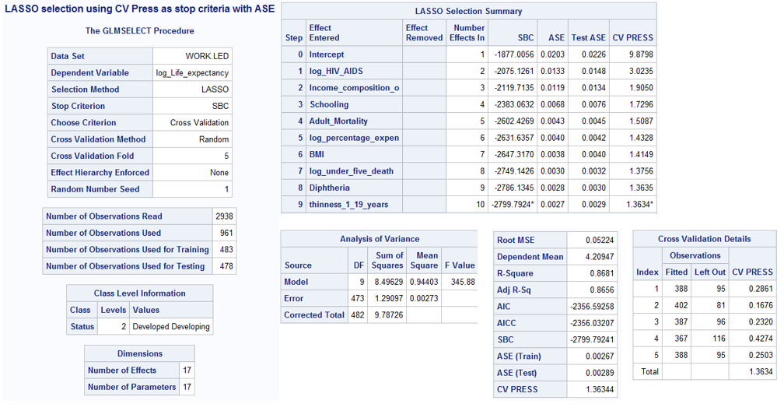

**PROC** **GLMSELECT** DATA= LED plots(stepaxis = number) = (criterionpanel ASEPlot) seed = **1**;

title "**LARS** selection using CV Press as stop criteria with ASE";

partition fraction(test = **.5**);

class Status;

model log_Life_expectancy= Year Adult_Mortality Alcohol log_percentage_expenditure Hepatitis_B log_Measles BMI log_under_five_deaths Polio Total_expenditure Diphtheria log_HIV_AIDS log_Population thinness_1_19_years Income_composition_of_resources Schooling / selection = lars( choose = cv) CVDETAILS;

output out = LARSsel ;

**run**;

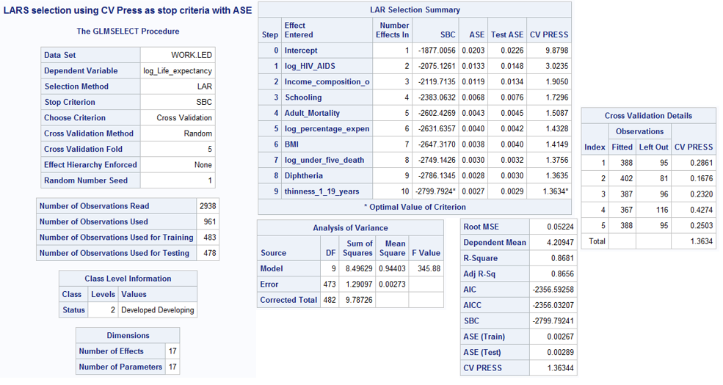

Both, Forward and Backward, selection methods have the least CV PRESS and ASE -Train and Test. Looking at the variables selected by each of the models, I will go ahead with the creating a custom model using the variables selected by ‘Forward selection’.

Custom Model:

**PROC** **GLM** DATA= LED plots = all;

title "Custom Model with variables selected from Forward model with STATUS interaction ";

class Status;

model log_Life_expectancy = log_HIV_AIDS Schooling Adult_Mortality Income_composition_of_resources log_percentage_expenditure log_under_five_deaths Diphtheria Alcohol thinness_1_19_years BMI log_HIV_AIDS*Status Schooling*Status Adult_Mortality*Status Income_composition_of_resources*Status log_percentage_expenditure*Status log_under_five_deaths*Status Diphtheria*Status Alcohol*Status thinness_1_19_years*Status BMI*Status / solution clparm ;

output out = Customsel ;

**run**;

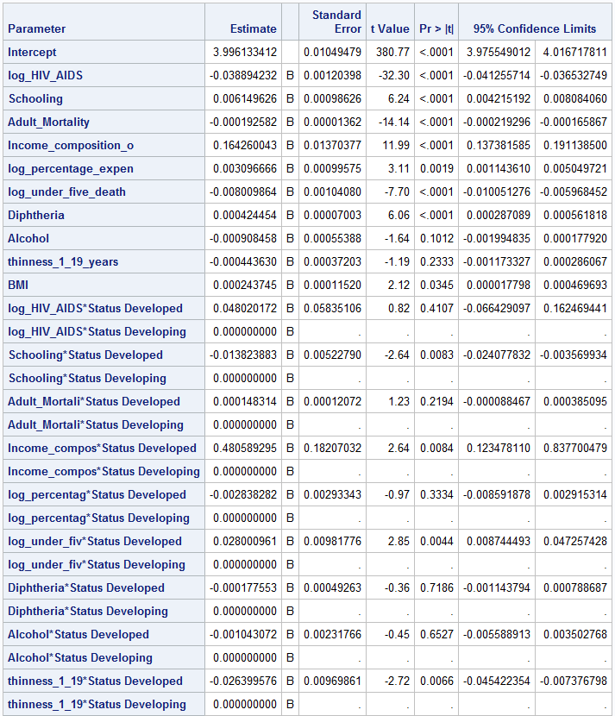



Removing all the statistically insignificant variables from the model:

**Revised Customer Model**

**PROC** **GLM** DATA= LED plots = all;

title "Custom Model with variables selected from Forward model with STATUS interaction ";

class Status;

model log_Life_expectancy = log_HIV_AIDS Schooling Adult_Mortality Income_composition_of_resources log_percentage_expenditure Diphtheria Income_composition_of_resources*Status / solution cli clparm ;

output out = Customsel ;

**run**;

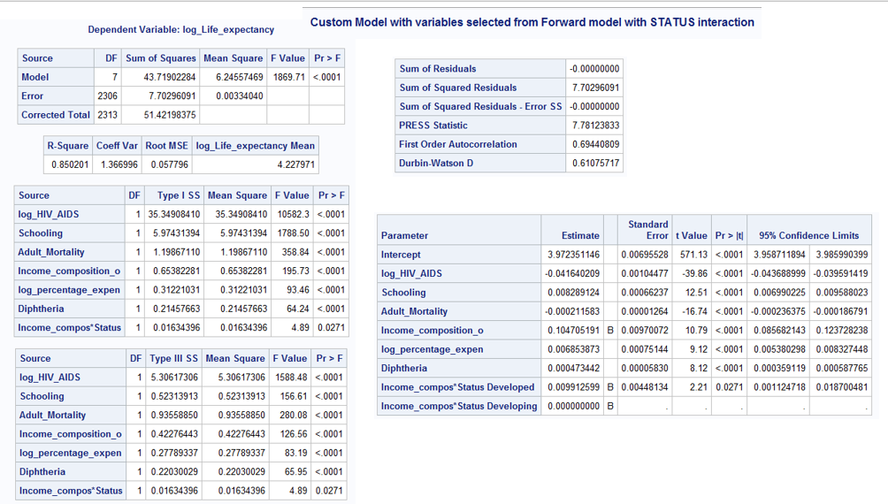

Outlier Analysis Graph 1 and Graph 2:

Outlier Analysis using all the variables in Model3: We see obs. 1128 has a very high cook’s D.

Cook’s D - Graph 1:

Cooks D Graph 2:

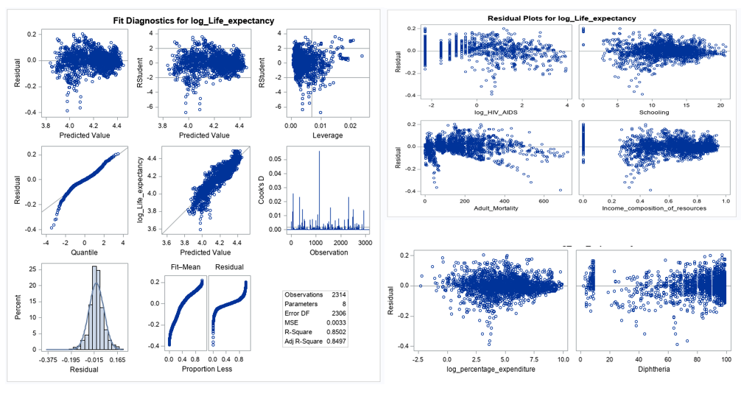

**Non-Parametric methods**

Regression Analysis Chart:

Cross Validation plot:

